

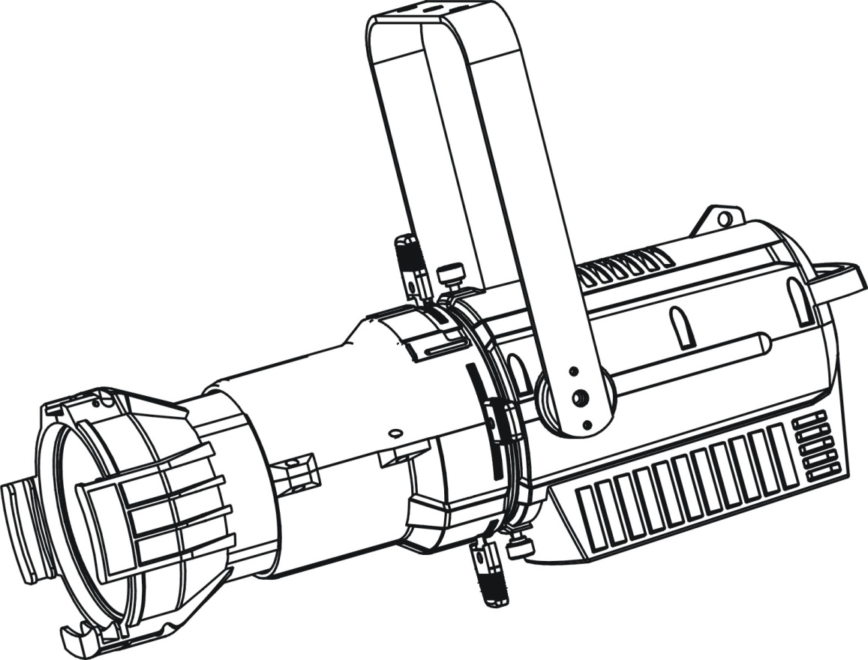

**TSL LED Profile 160 WW/36**

**User Manual** 

**Thank you for purchasing a THEATRE STAGE LIGHTING product. You have acquired a powerful and versatile fixture. We are confident that you will be satisfied with our excellent products and service. For your own safety, please read this user manual carefully before installing and operating the device.**

**CONTENTS**

1. SAFETY INSTRUCTIONS 2

2. FEATURES 4

3. FIXTURE OVERVIEW 6

4. DIMENSIONAL DRAWINGS 7

5. INSTALLATION INSTRUCTIONS 8

6. DMX-512 CONTROL CONNECTION 11

7. DMX-512 CONNECTION WITH DMX TERMINATOR 11

8. DEVICE DMX START ADDRESS SELECTION 12

9. DISPLAY 12

10. DMX PROTOCOL 21

11. OPTIONS 23

12. CLEANING AND MAINTENANCE 23

13. SERVICE 24

# SAFETY INSTRUCTIONS

* 1. IMPORTANT SAFETY WARNING

This device has left the factory in perfect condition.In order to maintain this condition and to ensure safe operation，it is absolutely necessary for the user to follow the safety instructions and warning notes written in this user manual.

In order to install，operate，and maintain the lighting fixture safely and correctly we suggest that the installation and operation be carried out by qualified technicians and these instructions be carefully followed.

|  |  |
| --- | --- |
| 图1 | **CAUTION!**  HIGH VOLTAGE. RISK OF SEVERE OR FATAL ELECTRIC SHOCK |
|  |  |
| 图4 | **CAUTION!**  ALWAYS DISCONNECT MAINS SUPPLY BEFORE REMOVING ANY FIXTURE COVERS |
|  |  |
| 图2 | **CAUTION!**  NEVER LOOK DIRECTLY INTO THE LIGHT SOURCE. SENSITIVE PERSONS MAY SUFFER AN EPILEPTIC SHOCK |
|  |  |
| 图3 | **CAUTION!**  NEVER TOUCH THE DEVICE DURING OPERATION! COVERS MAY BE HOT |

***Important:***



***Damage caused by the disregard of this user manual is not subject to warranty***.***The dealer and manufacturer will not accept liability for any resulting defects or problems***.

* If the device has been exposed to temperature changes due to environmental conditions， do not power on immediately.The resulting condensation could damage the device.Leave the device powered off until it has reached room temperature.
* Ensure only professional technicians perform maintenance on the fixture.To maintain the fixture’s IP65 rating，it is important to tighten screws properly following maintenance.
* Ensure the sealing rubber covers of oower CON and XLR connectors are fitted properly when the device is not in use，to avoid water ingress.
* This device falls under protection-class I.Therefore，it is essential that the device be earthed.
* If either lenses or display are damaged (damage may include cracks or gashes in the material) they must be replaced.
* Electrical connections，such as replacing the power plug，must be performed by a qualified person.
* Make sure that the available voltage is not higher than that which is stated at the end of this manual.
* Make sure the power cord is never crushed or damaged by sharp edges.If this should be the case，replacement of the cable must be done by an authorized dealer.
* If the external flexible power cord of this device is damaged，it shall be exclusively replaced by the manufacturer or their service agent or a similar qualified person in order to avoid injury.
* When the device is not in use or before performing maintenance，always disconnect the device from the mains. Only handle the power cord from the plug. Never pull the plug out of a socket by tugging the power cord.
* When powered on for the first time，some smoke or smell may occur. This is caused by coating on metal parts when heated and is normal. If you are concerned，please contact your distributor.
* Do not focus the beam onto flammable surfaces. The minimum distance between the exiting lens of the device and the illuminated surface must be greater than 0.5 meter.

**Please be aware that damage caused by any modifications to the device are not subject to warranty**. **Keep away from children and non-professionals**.

* 1. GENERAL GUIDELINES
* This device is a lighting effect for professional use on stages，in discotheques，theatres，etc. the device was designed for indoor.
* This fixture is only allowed to be operated within the maximum alternating current as stated in the technical specifications in section 2 of this manual.
* Handle the device with care，avoid shaking or using force when installing or maintaining the device.
* If you use the quick lock cam when rigging the device，make sure the quick lock fasteners are located in the quick lock holes correctly and securely.
* Operate the device only after having familiarized yourself with its functions. Do not permit operation by persons not qualified for operating the device. Most damage is the result of unprofessional operation.
* Please use the original packaging if the device is to be transported.
* The applicable temperature for the device is between -10°C to 45°C.Do not use the device outside of this temperature range.
* The light source of this luminaire is not replaceable; when the light source reaches its end of life the whole luminaire shall be replaced.

**For safety reasons，please be aware that all modifications to the device are forbidden**.

**If this device is operated in any way different to the ones described in this manual，the product may suffer damage and the warranty becomes void**. **Furthermore，any other operation may lead to short-circuits，burns，electric shocks etc**.

# FEATURES

|  |
| --- |
| **POWER SUPPLY** |
| * AC 100-240V~，50/60Hz |
| * Power Consumption：160W |
|  |
| **LIGHT SOURCE** |
| * LED：1 pcs power LED 160W |
| * LED Life：100,000H |
| * Color temperature：3000 K |
| * Luminous flux：11200 lm * CRI: ≥92Ra |
|  |
| **FEATURES** |
| * 3 Control channel modes：2/5/7 channels |
| * 2 Operation modes：DMX-512，Master / Slave mode |
| * Beam angle：36° |
| * Strobe effect with 1-25 flashes per second and pulse effect |
| * Dimmer：0%~100% full range dimming, 16bit dimming curve * Gamma: 2.0, 2.2, 2.4, 2.6，2.8, to fit for different cameras * Refresh rate: 900-1,500Hz, 25,000Hz * Control: RDM compatible * Flicker free Operation for TV * Manual focus * Smart control system of cooling fans * Changeable lenses tube   **GOBO SYSTEM** Rotating gobo wheel: Support "B" size metal. HT transparency gobos. Holder optional. Gobo OD: 86mm |
|  |
| **DISPLAY** |
| Friendly LCD display |
|  |
|  |
| **SOFTWARE** |
| Upgrades：fast and convenient through DMX cable with DMX-512 controller |
|  |
| **OTHER SPEC** |
| * IP Rating：IP 20 |
| * DMX connection: 3/5 pin in/out   **DIMENSION**   * Length 618mm * Width 269mm * Height 398mm |
| **WEIGHT** |
| Net weight：7,4kg |

**PHOTOMETRIC DATA**

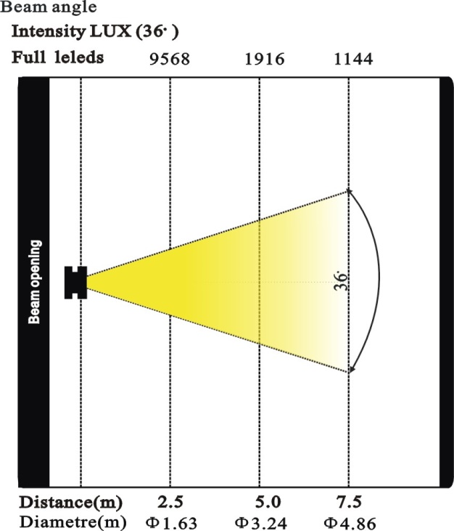

**DMX Channel Chart**

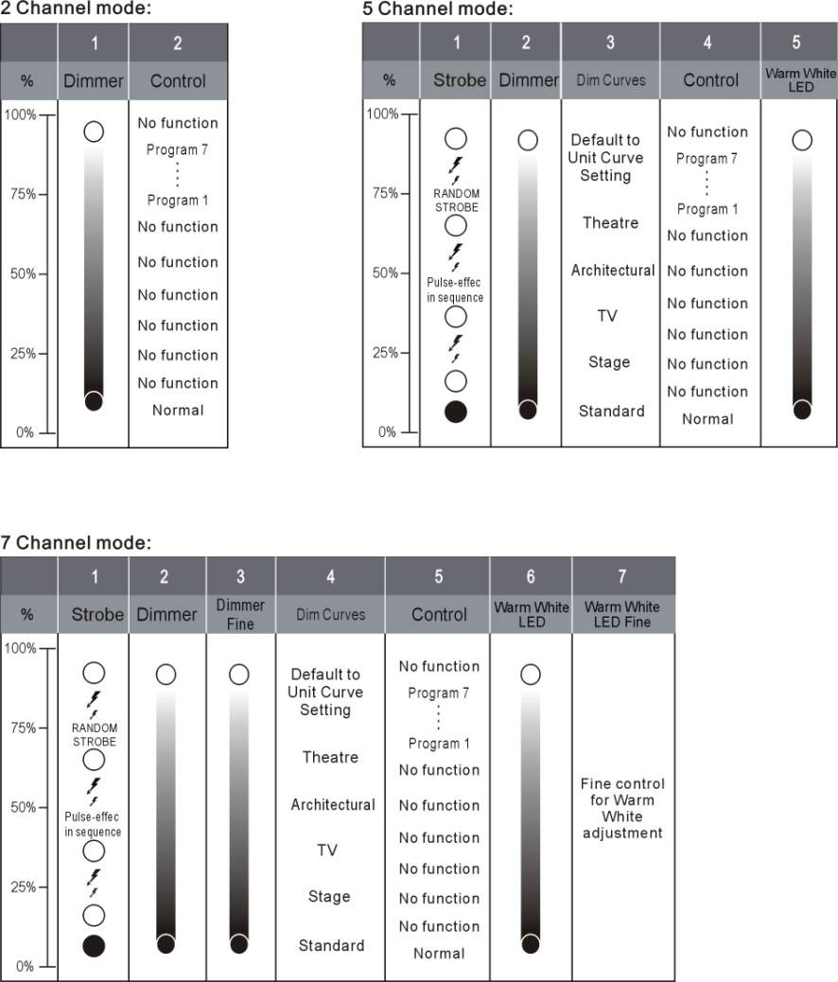

# FIXTURE OVERVIEW

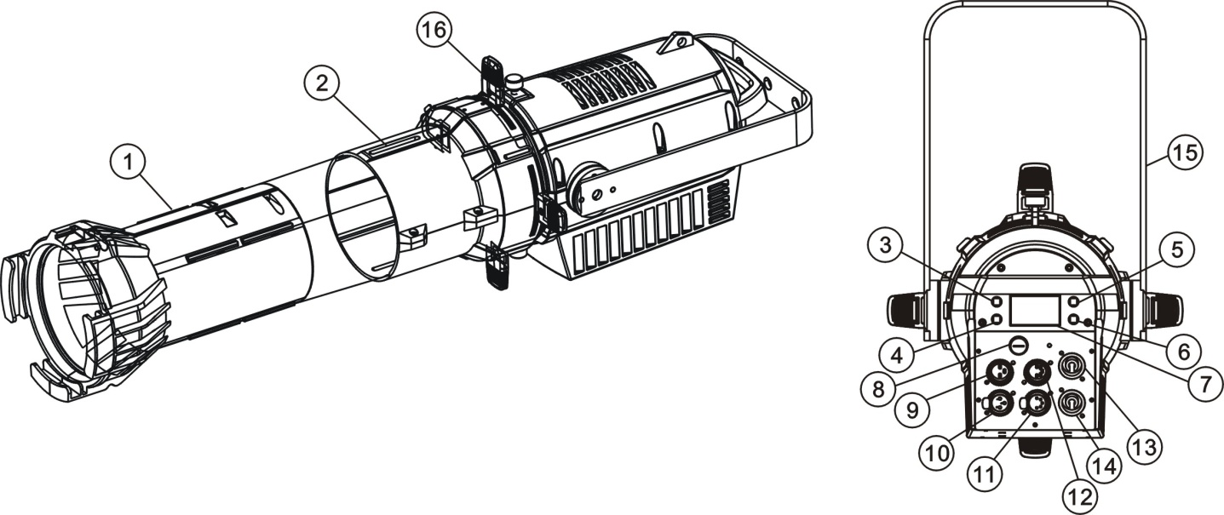

1. Lampshade (not included)
2. FOCUS
3. Up-button
4. Down-button
5. Mode/Esc-button
6. ENTER-button
7. LCD Menu Control Display
8. Fuse
9. 3-Pin DMX In
10. 3-Pin DMX Out
11. 5-Pin DMX Out
12. 5-Pin DMX In
13. Power In
14. Power Out
15. Floor-stand
16. Cutter

# DIMENSIONAL DRAWINGS

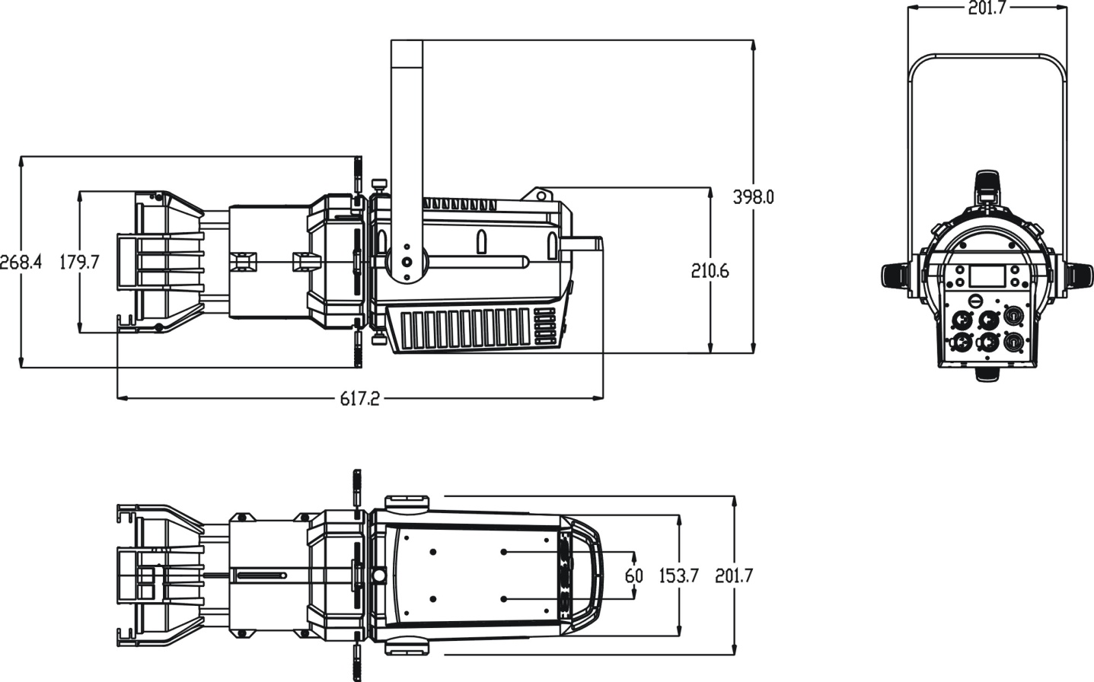

# INSTALLATION INSTRUCTIONS

1. 1. Rigging the device

|  |  |
| --- | --- |
| 图2 | **CAUTION!**  PLEASE CONSIDER THE RESPECTIVE NATIONAL NORMS DURING INSTALLATION. THE INSTALLATION MUST ONLY BE CARRIED OUT BY A QUALIFIED PERSON. |

* The applicable temperature for the lighting is between -10°C to 45°C. Do not use the lighting under or above the temperature.
* The installation of the effect has to be built and constructed in a way that it can hold 10 times the weight for 1 hour without any harming deformation.
* The installation must always be secured with a secondary safety attachment，e.g.an appropriate safety rope.
* Never stand directly below the device when mounting，removing or servicing the fixture.
* The operator has to make sure the safety relating and machine technical installations are approved by an expert before taking the device into operation for the first time.
* These installations have to be approved by a skilled person once a year.
* Overhead mounting requires extensive experience，including amongst others calculating working load limits，installation material being used，and periodic safety inspection of all installation material and the device. If you lack these qualifications，do not attempt the installation yourself. Improper installation can result in bodily injury.
  1. Rigging using the omega brackets

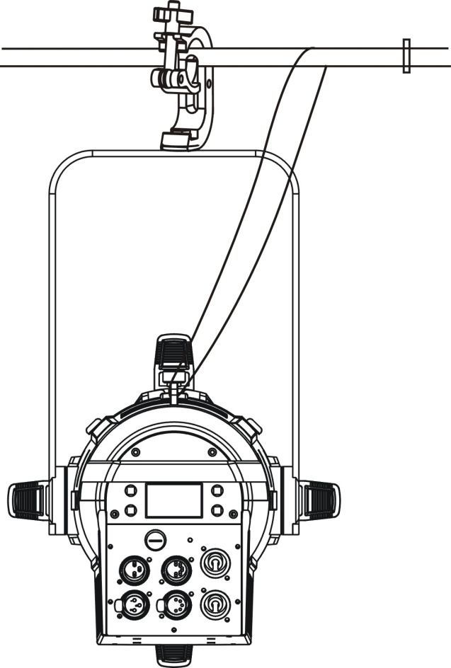

* Fix the clamp to the bracket by tightening the M12 nut and bolt to the bracket through the Ф13 hole in the middle of the bracket.
* Insert the quick-lock fasteners of the first Omega holder into the respective holes on the bottom of the device. Tighten the quick-lock fasteners fully clockwise.
* Install the second Omega holder.
* Pull the safety cable through the holes on the bottom of the base and over the trussing system or another suitable rigging point. Insert the end into the carabiner and tighten the safety screw.



**Important：**

**This step is very important to ensure safe rigging of the fixture**.

* 1. RIGGING DRAWINGS

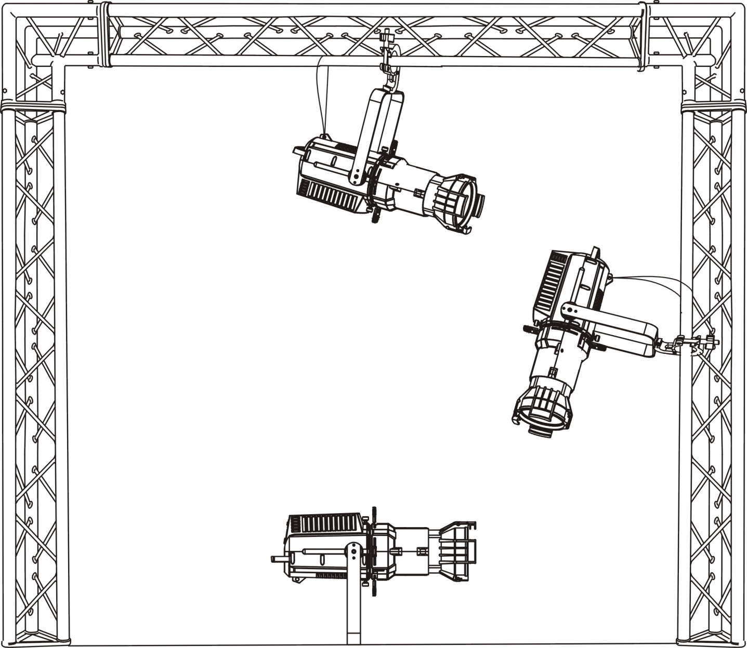

* Be sure this fixture is kept at least 0.5m away from any flammable materials (decoration etc.).
* Always use and install the supplied safety cable as a safety measure to prevent accidental damage and/or injury in the event the clamp fails.



**Important：**

**Overhead rigging requires extensive experience，including (but not limited to) calculating working load limits，specifying installation/ rigging materials，and periodic safety inspection of all installation material as well as the device**.**If you lack these qualifications，do not attempt the rigging of this device yourself**.**Improper installation/ rigging can result in serious bodily injury**.

# DMX-512 CONTROL CONNECTION

Connect the provided male side of the XLR cable to the female XLR output of your controller and the female side of the XLR cable to the male XLR input of the device.You can connect multiple devices together in a serial fashion.The cable needed should be two core，screened cable with XLR input and output connectors.Please refer to the diagram below.

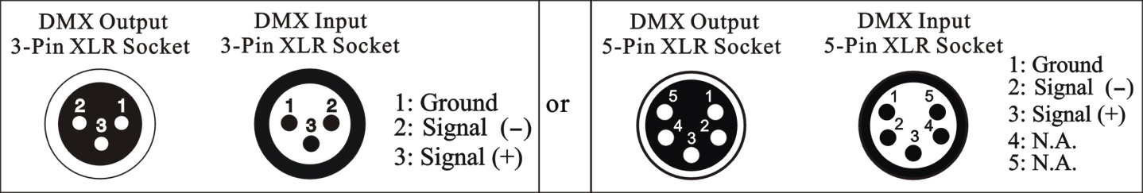

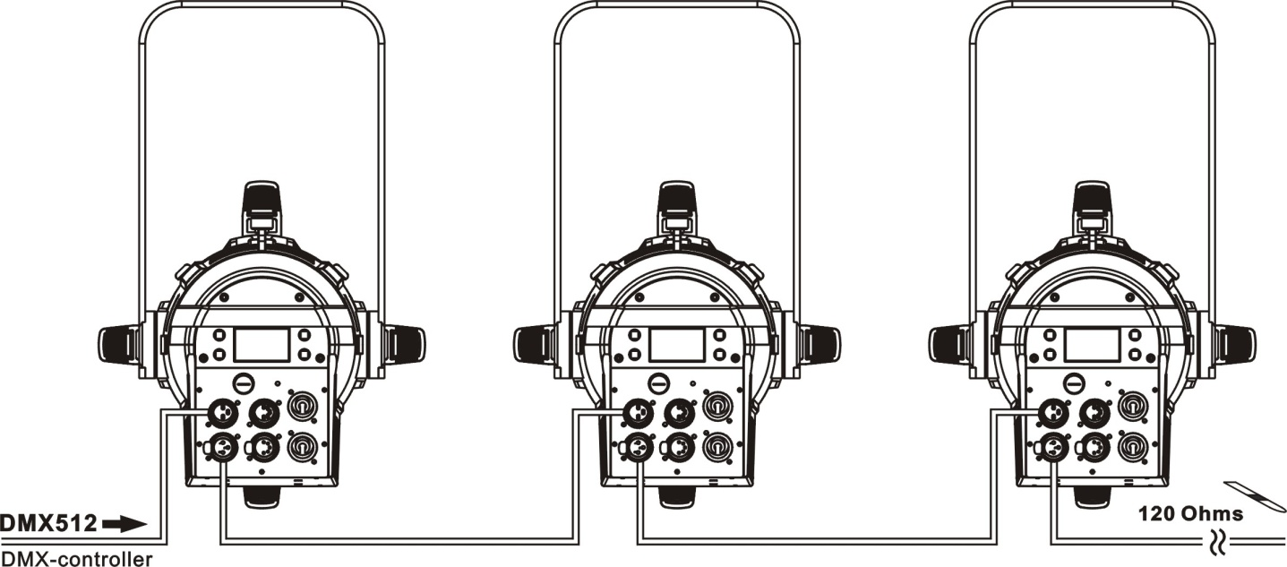

Address 1 Address 8 Address 15

# DMX-512 CONNECTION WITH DMX TERMINATOR

For installations where the DMX cable has to run over a long distance or is in an electrically noisy environment，such as in a discotheque，it is recommended to use a DMX terminator.This helps in preventing corruption of the digital control signal caused by electrical noise.The DMX terminator is an XLR plug with a 120 Ω resistor connected between pins 2 and 3，which is then plugged into the output (female) XLR socket of the last fixture in the chain.Please see illustrations below.

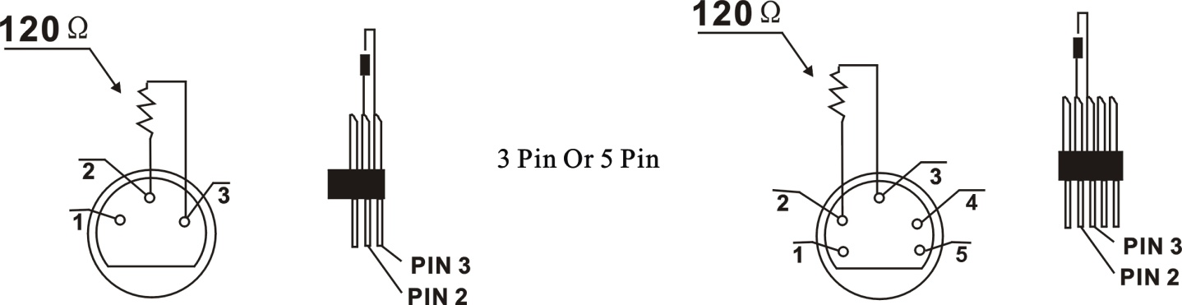

# DEVICE DMX START ADDRESS SELECTION

All fixtures should be given a DMX starting address when using a DMX signal，so that the correct fixture responds to the correct control signals.This digital starting address is the channel number from which the fixture starts to“listen”to the digital control information sent out from the DMX controller.The allocation of this starting address is achieved by setting the correct address number on the display located on the base of the device.

You can set the same starting address for all fixtures or a group of fixtures，or set different addresses for each fixture individually.

If you set the same address on all devices，all the devices will start to“listen”to the same control signal from the same channel number.In other words，changing the settings of one channel will affect all the fixtures simultaneously.

If you set a different address，each unit will start to“listen”to the channel number you have set，based on the quantity of control channels of the unit.That means changing the settings of one channel will affect only the selected device.

In the case of the fixture，in 7 channel mode，you should set the starting address of the first unit to 1，the second unit to 8 (7 + 1)，the third unit to 15 (7+ 8)，and so on.

# DISPLAY

The Display offers several features：you can set the starting address，run the pre-programmed program or reset the device.

The main menu is accessed by pressing the -button until the display starts flashing.Browse through the menu by pressing the C:\Users\GC64\Desktop\T90H-WW IP向上图标.JPG -button，C:\Users\GC64\Desktop\T90H-WW IP向下图标.JPG -button .Press the Enter-button in order to select the desired menu.You can change the selection by pressing the C:\Users\GC64\Desktop\T90H-WW IP向上图标.JPG -button，C:\Users\GC64\Desktop\T90H-WW IP向下图标.JPG -button.Confirm every selection by pressing theC:\Users\GC64\Desktop\T90H-WW IP确认图标.JPG -button.You can leave every mode by pressing the -button.After accessing the edit mode，the unit will automatically exit to the main menu after 15 seconds from the last button press.When the unit is powered on，if no data signal is connected after 1 minute，then the display will switch off automatically.The Display does not need external power to operate.Hold down the -button for 10 seconds and the Display will turn on by using the unit’s battery built in battery.

Default settings shaded

|  |  |  |  |  |  |  |  |
| --- | --- | --- | --- | --- | --- | --- | --- |
| FuncMode | Address  ValuDisp  SetSlave  AutoProg | 001~AXXX  All Ch….  Slave1,Slave2,Slave3  Master / Alone | | | | | DMX address setting  DMX value display  Slave setting  Auto program |
| Info | TimeInfo | Cur Time  TotalHrs  Last Hrs  TimePass  Clr Last | | XXXX(Hours)  XXXX(Hours)  XXXX(Hours)  Password=XXX  ON/OFF | | | Owe on running time  Fixture running time  Fixture Last times clear  Timer Password 038  Clear Fixture Last time |
| TempInfo | HeadTemp | | XXX℃/℉ | | | Temperature in the head |
| Soft Ver | 1.1.0…… | | | | | Software version |
| Persnal | Stat Set | Addr DMX  NoDMXSta | | ON/OFF  CloShut/**Hold**/Auto | | | Add. via DMX  Auto run if no DMX |
| Serv Set | Password  RDM UID | | Password=XXX  XXXXXX | | | Service Password“=050”  RDM UID Code |
| Disp Set | Off Time> | | 02~<60m> <05m | | | Display shutoff time |
| Key Lock | | ON/OFF | | | Key Lock |
| Temp C/F | Cels  Fahren | | | | | Temperature switch between ℃/℉ |
| Man Hold | ON/OFF | | | | | Man Hold |
| Refresh | 900~1200~1500, 2500,4000,5000,10K,15K,20K,25K (HZ) | | | | | Refresh |
| Gamma | 2.0,2.2,2.4,2.6,2.8 | | | | | Gamma |
| ResetDef | ON | | | | | Restore factory set. |
| OFF | | | | |
| ManCtrl | ManCntrl | Warm…  :  DiMo… | | | Warm =XXX  :  DiMo=XXX | | Fine adjustment of the lamp |
| Calibrat | password | | | =50 | | Password “050” |
| Warm | | | Warm =xxx | | Calibrate and adjust the effects to standard/right position |
| Mode Set | UserMode | 2CH  5CH  7CH | | | | | UserMode |
| Dimming | DimModes | **Standar**  Stage  TV  Archite  Theatre | | | | | DimModes |
| EditProg | Sel Prog | ProPart1  ProPart2  ProPart3 | Prog 1 ~ 10  Prog 1 ~ 10  Prog 1 ~ 10 | | | | Select programs to be run |
| EditProg | Prog 1  **:**  Prog 10 | ProgTest  EdStep01  ~EdStep64 | | | T01SCxxx  S01SCxxx  S64SCxxx | Testing program  Program in loop  Save and exit |
| EditScen | Scen001  ~ Scen250 | White,……  HoldTime  InByOut | | | White =xxx…  ON/OFF | Save and automatically return manual scenes edit |
| RecCntrl | XX~XX | | | | | Automat. scenes rec |

1. 1. **FUNCTION**

1. * 1. **Address**

With this function，you can adjust the desired DMX-address via the Display.

1. Access the main menu.
2. Tap the <Up/Down> button until“Address”is displayed.
3. Press< ENTER>，the display will show“Address”.
4. Tap the <Up/Down> button，the display will show“A001~AXXX”.
5. Press< ENTER> to confirm or press <MODE/ESC> to return to the main menu.
   * 1. **Value Disp**

With this function you can display the DMX 512 value of each channel.The display automatically shows the channel with a changing value.

1. Access the main menu.
2. Tap the <Up/Down> button until“Value Disp”is displayed.
3. Press< ENTER>，the display will show“Value Disp”.
4. Tap the <Up/Down> button，choose each channel.
5. Press< ENTER> to confirm or press <MODE/ESC> to return to the main menu.
   * 1. **Set Slave**

With this function, you can define the device as slave.

1. Access the main menu.
2. Tap the <Up/Down> button until“Set Slave”is displayed.
3. Press< ENTER>，the display will show“Set Slave”.
4. Tap the <Up/Down> button，the display will show“Slave1”，“Slave2”，“Slave3”.
5. Press< ENTER> to confirm or press <MODE/ESC> to return to the main menu.
   * 1. **Auto Program**

With this function，you can run the internal program.You can select the desired program under**“Select program”**.You can set the number of steps under“**Edit program”**.You can edit the individual scenes under**“Edit scenes”**.With this function，you can run the individual scenes either automatically，i.e.with the adjusted Step-Time.

1. Access the main menu.
2. Tap the <Up/Down> button until“Auto Program”is displayed.
3. Press< ENTER>，the display will show“Auto Program”.
4. Tap the <Up/Down> button，the display will show“Master”，“Alone”.
5. Press< ENTER> to confirm or press <MODE/ESC> to return to the main menu.
   1. **INFO**
   2. 1. **Time info**

**Cur Time**

With this function，you can display the temporary running time of the device from the last power on.The display shows“XXXX”，“XXXX”stands for the number of hours.The counter is reset after turning the device off.

1. Tap <MODE/ESC> button，access the main menu，Tap the <Up/Down> button until “Info”is displayed.Press< ENTER>，the display will show“Info”.Tap the <Up/Down> button until the display will show“Time Info”.Press< ENTER>， the display will show“Time Info”.
2. Press <Up/Down>，the display will show“Cur Time”.
3. Press< ENTER>，the display will show“Cur Time”.
4. The display will show“XXXX”(Hours).
5. Press <ENTER> to confirm or press <MODE/ESC> to return to the main menu.

**Total Hrs**

With this function，you can display the running time of the device. The display shows “XXXX”，“XXXX”stands for the number of hours.

1. Tap <MODE/ESC> button，access the main menu，Tap the <Up/Down> button until  “Info”is displayed. Press< ENTER>，the display will show“Info”.Tap the <Up/Down> button until the display will show“Time Info”.Press < ENTER>，the display will show“Time Info”.
2. Press <Up/Down>，the display will show“Total Hrs”.
3. Press< ENTER>，the display will show“Total Hrs”.
4. The display will show“XXXX”(Hours).
5. Press <ENTER> to confirm or press <MODE/ESC> to return to the main menu.

**Last Hrs**

With this function，you can display last the running time of the device. The display shows “XXXX”，“XXXX”stands for the number of hours.

1. Tap <MODE/ESC> button，access the main menu，Tap the <Up/Down> button until “Info”is displayed. Press< ENTER>，the display will show“Info”.Tap the <Up/Down> button until the display will show“Time Info”.Press< ENTER>，the display will show“Time Info”.
2. Press <Up/Down>，the display will show“Last Hrs”.
3. Press< ENTER>，the display will show“Last Hrs”.
4. The display will show“XXXX”(Hours) .
5. Press <ENTER> to confirm or press <MODE/ESC> to return to the main menu.

**Time Pass**

With this function，you can display the timer password.

1. Tap <MODE/ESC> button，access the main menu，Tap the <Up/Down> button until “Info”is displayed. Press< ENTER>，the display will show“Info”.Tap the <Up/Down> button until the display will show“Time Info”.Press< ENTER>，the display will show“Time Info”.
2. Press <Up/Down>，the display will show“Time Pass”.
3. Press< ENTER>，the display will show“Time Pass”.
4. The time password is 038.
5. Press <ENTER> to confirm or press <MODE/ESC> to return to the main menu.

**Clr Last**

With this function，you can clear last run time of the fixture.The display shows“ON”or “OFF”，Press“Enter”to confirm.

1. Tap <MODE/ESC> button，access the main menu，Tap the <Up/Down> button until “Info”is displayed. Press< ENTER>，the display will show“Info”.Tap the <Up/Down> button until the display will show“Time Info”.Press< ENTER>，the display will show“Time Info”.
2. Press <Up/Down>，the display will show“Clr Last”.
3. At“L-Timer Password”menu input right password，Press< ENTER>，the display will show“Clr Last”.
4. The display show“OFF”，Press <Up/Down>，the display will show“ON”.
5. Press <ENTER> to confirm or press <MODE/ESC> to return to the main menu.
   * 1. **Temp Info**

**Head Temp**

With this function you can display the temperature on the display board of the base (near CMY-filter) in Celsius.

1. Tap <MODE/ESC> button，access the main menu，Tap the <Up/Down> button until “Info”is displayed. Press< ENTER>，the display will show“Info”.Tap the<Up/Down> button until“Temp Info”is displayed. Press< ENTER>，the display will show“Temp Info”.
2. Press <Up/Down>，the display will show“Head Temp”.
3. Press< ENTER>，the display will show“Head Temp”.
4. The display show“XXX °C/ °F”.
5. Press <ENTER> to confirm or press <MODE/ESC> to return to the main menu.
   * 1. **Soft Ver**

With this function，you can display the software version of the device.

1. Tap <MODE/ESC> button，access the main menu，Tap the <Up/Down> button until “Info”is displayed. Press< ENTER>，the display will show“Info”.
2. Press <Up/Down>，the display will show“Soft Ver”.
3. Press< ENTER>，the display will show“Soft Ver”.
4. The display show“1.1.0......”.
5. Press <ENTER> to confirm or press <MODE/ESC> to return to the main menu.

* 1. **PERSONAL**
  2. 1. **Stat Set**

**Addr DMX**

With this function，you can adjust the desired DMX-address via an external controller.

1. Tap <MODE/ESC> button，access the main menu，Tap the <Up/Down> button until “Personal”is displayed. Press< ENTER>，the display will show“Personal”.Tap the <Up/Down> button until the display will show“Stat set”.Press< ENTER>，the display will show“Stat set”.
2. Press <Up/Down>，the display will show“Addr DMX”.
3. Press< ENTER>，the display will show“Addr DMX”.
4. The display show“ON”，Press <Up/Down>，the display will show“OFF” .
5. Press <ENTER> to confirm or press <MODE/ESC> to return to the main menu.

**No DMX Sta**

With this function，when the drive is not DMX signal，it runs automatism，close，hold and music，the default is hold.

1. Tap <MODE/ESC> button，access the main menu，Tap the <Up/Down> button until “Personal”is displayed. Press< ENTER>，the display will show“Personal”.Tap the <Up/Down> button until the display will show“Stat set”.Press< ENTER>，the display will show“Stat set”.
2. Press <Up/Down>，the display will show“No DMX Sta”.
3. Press< ENTER>，the display will show“No DMX Sta”.
4. The display show“Hold”，Press <Up/Down>，the display will show“CloShut”，“Hold”， “Auto”.
5. Press <ENTER> to confirm or press <MODE/ESC> to return to the main menu.
   * 1. **Serv Set**

**Password**

The Password for this function is“050”.

**RDM UID**

With this function you can call up various submenus via RDM.

1. Tap <MODE/ESC> button，access the main menu，Tap the <Up/Down> button until “Personal”is displayed. Press<ENTER>，the display will show“Personal”.Tap the <Up/Down> button until the display will show“Serv Set”. Press<ENTER>.the display will show“Serv Set”.
2. Press <Up/Down>，the display will show“RDM UID”.
3. Press< ENTER>，the display will show“RDM UID”.
4. The display show“XXXX”.
5. Press <ENTER> to confirm or press <MODE/ESC> to return to the main menu.
   * 1. **Disp Set**

**Off Time**

With this function you can shut off the LCD display after 2 to 60 minutes.The default is 5 minutes.

1. Tap <MODE/ESC> button，access the main menu，Tap the <Up/Down> button until “Personal”is displayed. Press<ENTER>，the display will show“Personal”.Tap the <Up/Down> button until the display will show“Disp Set”.Press<ENTER>，the display will show“Disp Set”.
2. Press <Up/Down>，the display will show“Off Time”.
3. Press< ENTER>，the display will show“Off Time”.
4. The display show“05m”，Press <Up/Down>，the display will show“02~60m”.
5. Press <ENTER> to confirm or press <MODE/ESC> to return to the main menu.

**Key Lock**

With this function you can activate the automatic key lock function. If this function is activated，the keys will be locked automatically after exiting the edit mode for 15 seconds. keeping press the <MODE/ESC> key for 3seconds if you do not need this function.

1. Tap <MODE/ESC> button，access the main menu，Tap the <Up/Down> button until “Personal”is displayed. Press < ENTER>，the display will show“Personal”.Tap the <Up/Down> button until the display will show“Disp Set”.Press< ENTER>，the display will show“Disp Set”.
2. Press <Up/Down>，the display will show“Key Lock”.
3. Press< ENTER>，the display will show“Key Lock”.
4. The display show“OFF”，Press <Up/Down>，the display will show“ON”.
5. Press <ENTER> to confirm or press <MODE/ESC> to return to the main menu.
   * 1. **Temp C/F**

With this function you can display the temperature in Celsius or Fahrenheit.

1. Tap <MODE/ESC> button，access the main menu，Tap the <Up/Down> button until “Personal”is displayed. Press<ENTER>，the display will show“Personal”.
2. Press <Up/Down>，the display will show“Temp C/ F”.
3. Press< ENTER>，the display will show“Temp C/F”.
4. The display show“Celsius”，Press <Up/Down>，the display will show“Fahrenheit”.
5. Press <ENTER> to confirm or press <MODE/ESC> to return to the main menu.
   * 1. **Man Hold**

With this function you can display man hold.

1. Tap <MODE/ESC> button，access the main menu，Tap the <Up/Down> button until “Personal”is displayed. Press<ENTER>，the display will show“Personal”.
2. Press <Up/Down>，the display will show“Man Hold”.
3. Press< ENTER>，the display will show“Man Hold”.
4. The display show“OFF”，Press <Up/Down>，the display will show“ON”.
5. Press <ENTER> to confirm or press <MODE/ESC> to return to the main menu.

* + 1. **Refresh**

1. Tap <MODE/ESC> button，access the main menu，Tap the <Up/Down> button until “Personal”is displayed. Press<ENTER>，the display will show“Personal”.
2. Press <Up/Down>，the display will show“Refresh”.
3. Press< ENTER>，the display will show“Refresh”.
4. The display shows“1200”，Press <Up/Down>，the display will show “900~1200~1500”，“2500”，“4000”，“5000”，“10K”，“15K”，“20K”，“25K”.
5. Press <ENTER> to confirm or press <MODE/ESC> to return to the main menu.
   * 1. **Gamma**
6. Tap <MODE/ESC> button，access the main menu，Tap the <Up/Down> button until “Personal”is displayed. Press< ENTER>，the display will show“Personal”.
7. Press <Up/Down>，the display will show“Gamma”.
8. Press< ENTER>，the display will show“Gamma”.
9. The display show“2.2”，Press <Up/Down>，the display will show“2.0”，“2.2”，“2.4”，“2.6”，“2.8”.
10. Press <ENTER> to confirm or press <MODE/ESC> to return to the main menu.
    * 1. **Reset Def**

With this function，you can select restore factory set for ON or OFF，the default is OFF.

1. Tap <MODE/ESC> button，access the main menu，Tap the <Up/Down> button until “Personal”is displayed. Press< ENTER>，the display will show“Personal”.
2. Press <Up/Down>，the display will show“Reset Def”.
3. Press< ENTER>，the display will show“Reset Def” .
4. The display show“OFF”，Press <Up/Down>, the display will show“ON”.
5. Press <ENTER> to confirm or press <MODE/ESC> to return to the main menu.
   1. **MANCTRL**
   2. 1. **Man Cntrl**

When set to Manual Mode，fixture will be back to factory settings.If want to adjust brightness，can adjust by shutter and dimming channel，channel value is 0-255.Other functions can be set according to user's real need.

1. Tap <MODE/ESC>button，access the main menu，Tap the <Up/Down>button until “ManCtrl”is displayed. Press< ENTER>，the display will show“ManCtrl”.
2. Press <Up/Down>，the display will show“Man Cntrl”.
3. Press< ENTER>，the display will show“Man Cntrl”.
4. The display show“Warm =XXX：DiMo=XXX”.
5. Press <ENTER> to confirm or press <MODE/ESC> to return to the main menu.
   * 1. **Calibrat**

With this function，you can calibrate and adjust the effect wheels to their correct positions.The password of calibrate values is 050.

1. Tap <MODE/ESC> button，access the main menu，Tap the <Up/Down> button until “ManCtrl”is displayed.Press ENTER，the display will show“ManCtrl”.
2. Press <Up/Down>，the display will show“Calibrat”.
3. Press< ENTER>，the display will show“Calibrat”.
4. The display show“Warm=XXX”.
5. Press <ENTER> to confirm or press <MODE/ESC> to return to the main menu.
   1. **MODE SET**
   2. 1. **User Mode**

With this function，you can create user defined channel orders.

1. Tap <MODE/ESC> button，access the main menu，Tap the <Up/Down> button until “Mode Set”is displayed. Press <ENTER>，the display will show“Mode Set”.
2. Press <Up/Down>，the display will show “User Mode”.
3. Press< ENTER>，the display will show“User Mode”.
4. The display show“2CH”，Press <Up/Down> button，then you can choose“2CH”，“5CH”，“7CH”.
5. Press <ENTER> to confirm or press <MODE/ESC> to return to the main menu.

* 1. **DIMMING**

**Dim Modes**

With this function，you can display the dimming modes.

1. Tap <MODE/ESC> button，access the main menu，Tap the <Up/Down> button until “Dimming”is displayed. Press <ENTER>，the display will show“Dimming”.
2. Press <Up/Down>，the display will show “Dim Modes”.
3. Press< ENTER>，the display will show“Dim Modes”.
4. The display show“Standar”，Press <Up/Down> button，then you can choose“Stage”，“TV”，“Archite”，“Theatre”.
5. Press <ENTER> to confirm or press <MODE/ESC> to return to the main menu.
   1. **EDIT PROG**
6. Tap <MODE/ESC> button，access the main menu，Tap the <Up/Down> button until “Edit Prog” is displayed. Press<ENTER>，the display will show“Edit Prog”.
7. The display show“Sel Prog”，Press <Up/Down>，the display will show“Edit Prog”，“Edit Scen”，“Rec Cntrl”.
8. Press <ENTER> to confirm or press <MODE/ESC> to return to the main menu.

Run the auto program：A master fixture can output to three different program signals to the slave fixture to operate.It means the host will send cyclically in the following orders (The host will keep operating the program of Part 1) Then the slave fixture will make the selectively receiving according to its own set.



1. If the slave fixture chooses Run For Slave 1 from the menu of 1-3,then it will receive the part 1’s automatic program from link，in the same way，when the slave fixture chooses Run For Slave 2，then it will receive the part 2’s automatic program from link.
2. Enter the menu of 1-3 Function Mode---Set To Slave，Here to set machine operate which part of the program during the host-slave connection
3. Enter the menu of 1-4，1-5 Function Mode---Set To Master
4. Enter the menu of 8-1 Edit Program---Auto Program Part1.The host outputs three groups driven program---Part1，Part2，Part3(Part1 program runs the same effect as the host)
5. Enter the menu of 8-2 Edit Program---Edit Program.Edit the program’s connection， connect the scene in order
6. The editor of the scene，there are as many as 250 scenario editors，and every scene can have a program connection of 10.

**Note:**

Part 2，Part 3 repeat in accordance with the Part1’s repeat.For example：When Part 1 uses Program 2，Part 2 uses Program 4，Part 3 uses Program 6，Assume：Program 2 includes scene of 10，11，12，13；Program 4 includes scene of 8，9，10；Program 6 includes scene of 12，13，14，15；Then it will run as below.

Example：



1. DMX PROTOCOL

|  |  |  |  |  |  |  |
| --- | --- | --- | --- | --- | --- | --- |
| **DMX channel´s functions and their values (2\5\7 DMX channels):** | | | | | | |
| **Mode/Channel** | | | **Value** | **Function** | **Default Dmx** | **Time/Speed** |
| **2CH** | **5CH** | **7CH** |  |  |  |  |
| NA | 1 | 1 |  | **Shutter, strobe:** | 32 |  |
| 0-31 | Led trun off |  |
| 32-63 | Led turn on |  |
| 64-95 | Strobe effect slow to fast | 1-25HZ |
| 96-127 | Led turn on |  |
| 128-159 | Pulse-effect in sequences | 1-25HZ |
| 160-191 | Led turn on |  |
| 192-223 | Random strobe effect slow to fast |  |
| 224-255 | Led turn on |  |
| 1 | 2 | 2 |  | **Dimmer intensity:** | 0 |  |
| 0-255 | Intensity 0 to 100% |
| NA | NA | 3 |  | **Fine Dimmer intensity:** | 0 |  |
| 0-255 | Dimmer intensity fine |
| NA | 3 | 4 |  | **Dim Curves:** | 0 |  |
| 0-20 | Standard |
| 21-40 | Stage |
| 41-60 | TV |
| 61-80 | Architectural |
| 81-100 | Theatre |
| 101-255 | Default to Unit Curve Setting |

|  |  |  |  |  |  |  |
| --- | --- | --- | --- | --- | --- | --- |
| **Mode/Channel** | | | **Value** | **Function** | **Default Dmx** | **Time/Speed** |
| **2CH** | **5CH** | **7CH** |  |  |  |  |
| 2 | 4 | 5 |  | **Special Control:** | 0 |  |
| 0-79 | Normal |
| 80-84 | No function |
| 85-87 | No function |
| 88-90 | No function |
| 91-93 | No function |
| 94-96 | No function |
| 97-99 | No function |
| 100-119 | Internal program 1(secne1~8 of EEPROM) |
| 120-139 | Internal program 2(secne9~16 of EEPROM) |
| 140-159 | Internal program 3(secne17~24 of EEPROM) |
| 160-179 | Internal program 4(secne25~32 of EEPROM) |
| 180-199 | Internal program 5(secne33~40 of EEPROM) |
| 200-219 | Internal program 6(secne41~48 of EEPROM) |
| 220-239 | Internal program 7(secne49~56 of EEPROM) |
| 240-255 | No function |
| NA | 5 | 6 |  | **Warm White LED 1 :** | 255 |  |
| 0-255 | Warm White ( 0-Black , 255-100% White ) |
| NA | NA | 7 |  | **Warm White LED Fine 1 :** | 0 |  |
| 0-255 | Fine control for Warm White adjustment |

1. OPTIONS

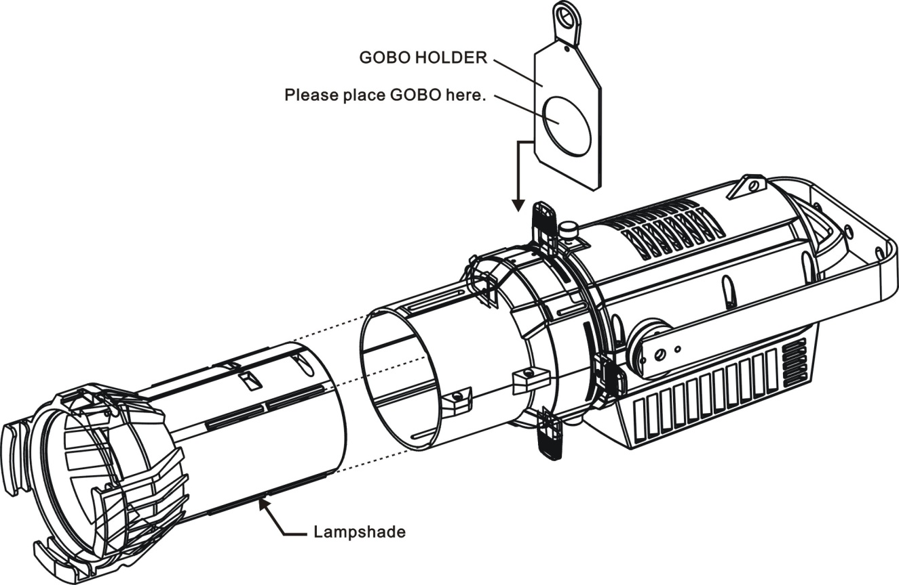

1. CLEANING AND MAINTENANCE

The following points have to be considered during inspection：

1) All screws for installing the devices or parts of the device have to be tightly connected and must not be corroded.

2) There must not be any deformations to the housing，lenses，rigging and installation points (ceiling，suspension，trussing).

3) Motorized parts must not show any signs of wear and must move smoothly without issue.

4) The power supply cables must not show any damage，material fatigue or sediment.

Further instructions depending on the installation location and usage have to be adhered to by a qualified installer and any safety concerns have to be removed.



In order to ensure the device remains in good condition and does not fail prematurely，we suggest regular maintenance.

1)  Clean the inside and outside lens each week to avoid loss of output due to accumulation of dust/ dirt on the lens.

2)  Clean the fans each week to ensure maximum airflow and efficient thermal cooling.This will ensure the light source is operated in the best possible condition.

3)   A detailed electrical check by an approved electrician every quarter to make sure that the circuit contacts are in good condition.This will prevent poor circuit contacts and the resultant overheating.

We recommend frequent cleaning of the device.Please use a moist，lint- free cloth.Never use alcohol or solvents.

Please refer to the instructions under“Installation instructions”.

Should you need any spare parts，please order genuine parts from your local dealer.